CARBONATE & CLASTIC SEQUENCE STRATIGRAPHY
With applications to hydrocarbon exploration and production
Course instructor: Professor Dorrik Stow FRSE

Sequence stratigraphy concerns the description and interpretation of a succession of sedimentary strata, generally in a time-stratigraphic context. This is the standard methodology employed by industry to elucidate stratal stacking patterns and key bounding surfaces, and to erect a framework allowing depositional facies to mapped and interpreted paleogeographically. Traditionally, sedimentary successions are interpreted in terms of sea-level changes, using seismic sequence stratigraphic analysis in the first phases of exploration. Carbonate and clastic sequences respond very differently to sea-level. Both systems are also strongly affected by tectonic activity, which may override sea-level in certain settings. The effects of tectonic activity and tectonic pulsing on sequence stratigraphy will be investigated.

This course presents the fundamentals of sequence stratigraphy for both carbonate and clastic systems. It explores the differences between the two systems, and the role of sea-level versus tectonic control. It considers both seismic and sedimentary attributes and their interpretation in terms of depositional systems and environments.

Outline:
- Introduction, Stratigraphy, Sequence Stratigraphy, Sedimentology
- Continental/Shallow Marine depositional systems and sequence stratigraphy
- Carbonate depositional systems and sequence stratigraphy
- Deepwater depositional systems and sequence stratigraphy
- Summary, Participant presentations and discussion

Case studies: All sessions illustrated with modern, ancient and subsurface case studies Exercises: All sessions involve both lectures and hands-on practical components Course manual and PowerPoint sets provided

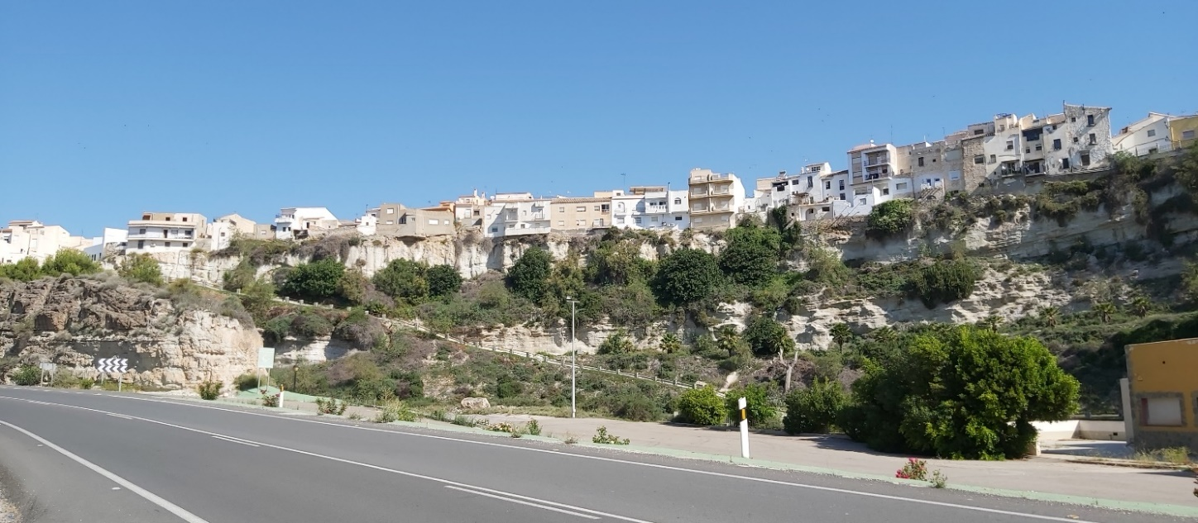

Sorbas village, SE Spain sits above a shallowing-up coastal to littoral, carbonate-clastic depositional parasequence

