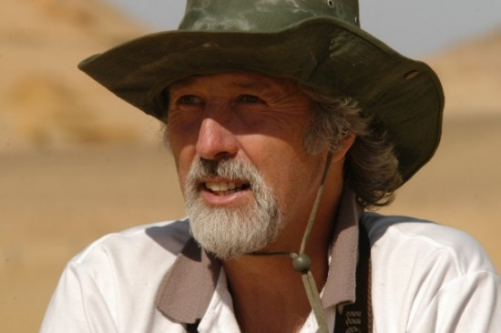

VANISHED OCEAN: How Tethys Re-shaped the World
Dorrik Stow, Plenary Lecture
International Geological Congress, 2024, Busan, South Korea

A hundred million years ago, a mighty ocean dominated the equatorial world. Its vast waters bore witness to many of most dramatic episodes in the story of our planet. It played host to a plethora of fascinating organisms, saw great mass extinctions and then nurtured the ensuing rebirth of new life forms. It endured its own secret drama of submarine quakes and powerful currents, at one point quaking under evening skies lit by the outpourings of a super-volcano that exploded along its northern margin. For long ages, its quiet central gyres were more desolate and empty than anything seen in today's world. But then, five and a half million years ago, it quite simply disappeared.

It was called the Tethys Ocean and this is a kaleidoscope of images from that lost world, pieced together from myriad clues, which are now scattered through the rocks that stretch from Morocco to China, from the depths of the Caspian Sea to the highest Himalayan peaks. Though imperfect and incomplete, the record is varied and captivating, telling something of the assembly and splintering of continents, the rise and fall of mountain ranges, the changing ocean currents and their link to Earth’s climate, the remarkable story of oil and gas, and other deep-ocean treasures. So too do they provide an alternative view of mass extinction events and the demise of the dinosaur world. Such changes in the land and ocean have been strongly instrumental in shaping the colourful pageant of life through the past 250 million years of Earth history, and in painting the template for the oceans of today.

Professor Dorrik Stow, Heriot-Watt University, Edinburgh, Scotland

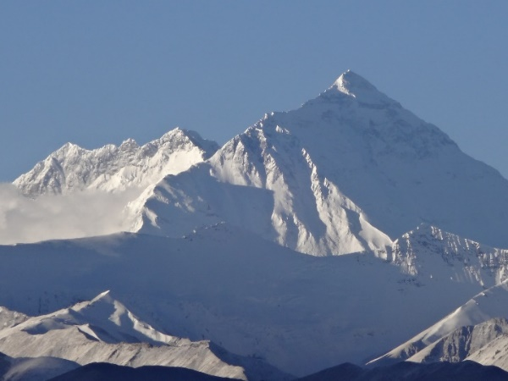
Everest from Tibet: pulsed uplift

HEARTBEAT OF THE EARTH
Dorrik Stow, Plenary Lecture
Mediterranean Geoscience Union 2023, Istanbul, Turkey

If we could listen with a geological stethoscope to the Earth’s deep interior, we would detect a slow but strong heartbeat, often irregular but with a beat of about one million years duration. Though driven from the core, this has a dramatic effect at the surface of the planet – volcanoes, earthquake clusters and massive submarine landslides, mountain building and even the behaviour of our magnetic shield. It is a beat that we are only just beginning to understand, and one that is too easily masked by white noise from a hundred and one other Earth processes, many of which show a remarkably regular cyclicity.

This talk reveals the nature, causes and effects of some of the most curious and significant of these cycles, for which scientists have gathered a wealth of evidence – the diurnal pulse of tides, the march of seasons, monsoonal rains and droughts, deep-ocean turmoil, ice ages and past climate change. These are mostly driven by external forces, such as the moon and sun (diurnal and decadal cycles) and planetary orbit (10s to 100s of thousand year cycles). It then explores lesser known cycles that we believe are driven internally – volcanic hot spots and superplumes, magnetic reversal of the north and south poles, and long-term tectonic pulsing. These are the true heartbeat of Earth. Although we can begin to unravel their cause and effects, we don’t yet why they occur nor know how to measure their tectonic pulse.

The research has been made possible by the award of a Leverhulme Emeritus Fellowship to the author, and is funded by The Leverhulme Trust

Professor Dorrik Stow, Heriot-Watt University, Edinburgh, Scotland

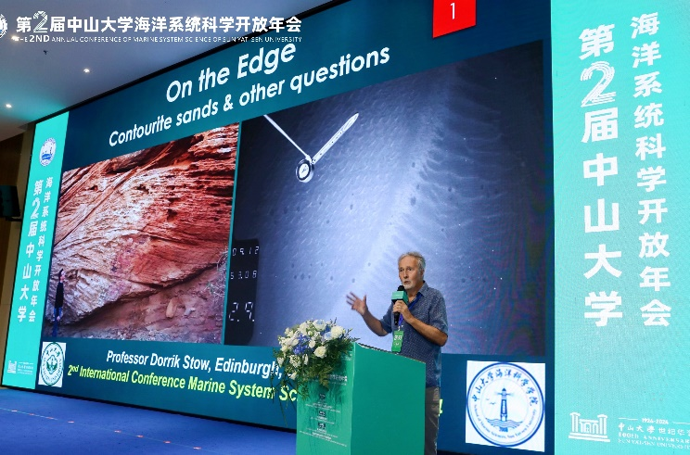

ON THE EDGE: Contourite Sands from Shelf to Slope
Dorrik Stow, Plenary Lecture
Annual Conference on Marine System Science 2024, Zhuhai, China

Whereas contourites and bottom currents have traditionally been considered the preserve of deepwater systems, it has become increasingly apparent that bottom-current influenced drifts and sand sheets are also characteristic of outer shelf and upper slope sedimentation. These drifts and sheets are deposited and reworked by (a) surface currents acting at the seafloor, (b) downwelling currents, (c) internal tides and waves, (d) high-energy meso-scale eddies, and (e) a combination of seafloor polishing and spillover processes. Collectively, the deposits of such systems should be referred to as shallow-water contourites. They have been described from a number of recent shelf-slope systems, including the outer Campos basin, the Hebridean margin, the Canterbury basin, the northern Adriatic Sea, the Aegean Sea, the Maldives and the Ryuku Island region. Several ancient examples are also known, including the Miocene Rifean Gateway system of Morocco.
Many of these deposits are sand-rich or have a prominent sandy component. Sandy contourite facies models are markedly different from the standard bi-gradational facies model for finer-grained contourites (mud-sand-mud). They typically show current-induced sedimentary structures (parallel and cross-lamination, and dune cross-bedding), together with large-scale bioturbation. Textural properties show that the fine and very-fine sands are clearly controlled by normal bottom-current transport and deposition. They show increased winnowing and improved sorting with increasing grain size (to around 200 microns). There is a need to modify the sortable silt criteria, commonly used for inferring bottom-current transport and speed, to include fine sand, and also for carbonate-rich contourites. Medium and coarse-grained sandy contourites, by contrast, show the effects of intermittent bedload transport and winnowing.
Detailed work in the Gulf of Cadiz region traces the transfer of sands from the outer shelf region and from seafloor erosion in the Gibraltar Gateway, to supply the mid-slope Cadiz sand sheet. Following transfer of material across this contourite terrace for over 100 km alongslope, sands are fed into the Cadiz Contourite Channel. During transport of material through this channel, both alongslope and downslope, by the lower core of the Mediterranean Outflow Water, it is also strongly influenced by focused deepwater tidal currents within the Cadiz Channel.

