Dorrik Stow: Popular Science books

Future titles in progress

Stow, D.A.V., Heartbeat of the Earth (Leverhulme Fellowship project). Completion end 2026

Dorling Kindersley The Ocean Book: the stories, science and history of oceans Wonders 2025

Books completed

Dorling Kindersley, 2022. Science of the Earth, Senior editors: P. Frances, D. Turner. Consultant and contributor

Dorling Kindersley, 2020. Science of the Ocean, Senior editors: P. Frances, D. Turner. Consultant and contributor

Stow, D.A.V. 2017. Oceans: A Very Short Introduction (Oxford University Press).

Stow, D.A.V. 2010. Vanished Ocean, (Oxford University Press), 300pp.

Stow DAV, 2006. Oceans: An Illustrated Reference, Chicago University Press (2nd Edition), 256pp.

Stow DAV, 2004. Encyclopedia of the Oceans, Oxford University Press (Europe) and Oceans: An Illustrated Reference, Chicago University Press (North America), 256pp.
Translations: Chinese, Japanese

Children’s books: completed (consulting editor/contributing author*)

- Galapagos, Dorling Kindersley, 2022
- The Earth Atlas, Dorling Kindersley, 2022
- Mysteries of the Ocean, Magic Cat Publishing, 2022
- Knowledge Encyclopedia: Ocean, Dorling Kindersley, 2020*
- Ocean: A Children’s Encyclopedia, Dorling Kindersley, 2015
- Ocean: An Incredible tour of the world’s oceans, Dorling Kindersley, 2010
- Rocks, Minerals and Fossils, Usborne, 2009
- Eyewitness: Water, Dorling Kindersley, 2009
- Oceans, Toucan Publishing, 2008
- Oceans: On-Line, Dorling Kindersley, 2008
- Oceans Atlas, Dorling Kindersley, 2007
- See Under the Ground, Usborne, 2007
- Under the Ground, Usborne, 2006
- Exploring the Ocean (Vols. 1-4), Oxford University Press, 2003

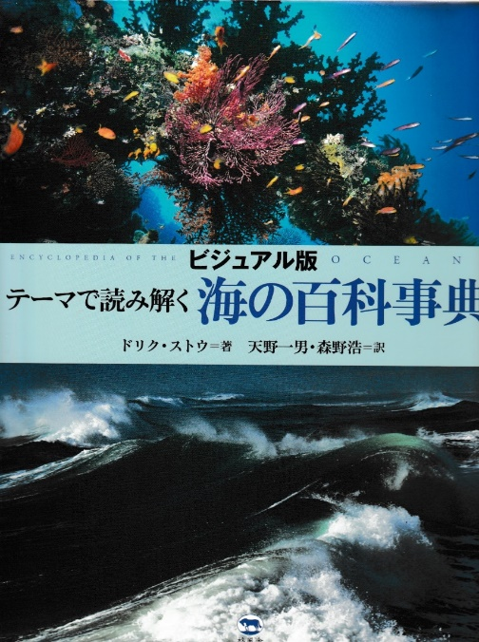
Stow, 2004, Encyclopedia of the Oceans, Oxford University Press
Stow 2005, Oceans: An Illustrated Reference, Chicago University Press
Stow, 2008, Oceans – Japanese translation by Amano & Morino

This is a groundbreaking reference work and beautifully illustrated coffee-table book. The stunning photographs, artwork and maps combine with an accessible and authoritative text by internationally acclaimed oceanographer and geologist, Dorrik Stow. There is a wealth of absorbing information and incredible facts on all aspects of the oceans, from their origins over four billion years ago to the hidden riches and environmental fragility they present today.
Few other books range across so many topics with such fluidity and command – the formation and destruction of ocean crust, patterns and cycles on the seafloor, rogue waves and internal tides, silent currents and hidden waterfalls, as well as the astonishing diversity and lifestyles of complex marine communities. This is an invaluable and delightful guide to Earth’s final frontier.

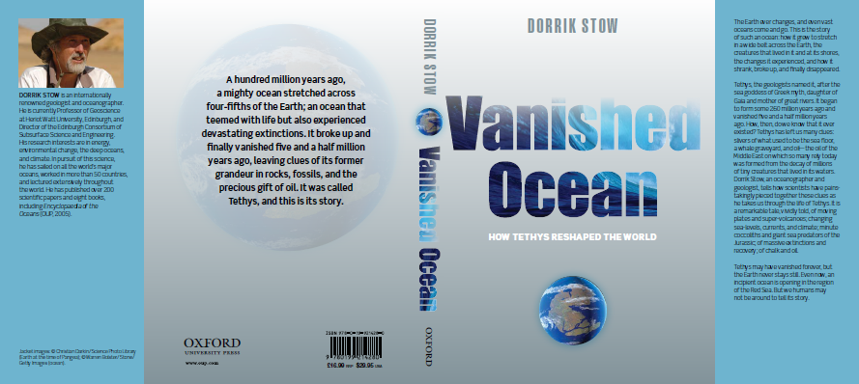
Stow, D.A.V. 2010. Vanished Ocean, (Oxford University Press), 300pp.
World-renowned geologist, Dorrik Stow, tells the story of a long-lost ocean – named Tethys Ocean after the Greek goddess of the sea. Tethys lasted for 250 million years of Earth history, straddling the equatorial world and playing host to the changing life and events that have shaped the planet we inhabit today. Tethys teemed with colourful life but also experienced devastating mass extinctions, bore witness to unparalleled climate change and experienced the highest sea levels ever recorded. It finally disappeared just as early humans marvelled at its shores.
For many years, Dorrik Stow has sought clues of this past ocean hidden in the rocks of many continents and buried beneath ocean floors. Here he brings to life its rich legacy and explains how it vanished.

Dorling Kindersley, 2020. Science of the Ocean, Senior editors: P. Frances, D. Turner. Dorrik Stow: Consultant and contributor

This utterly beautiful introduction the ocean world – in all its power, mystery and intrigue – captivates me every time I open it. The photography is stunning, jumping out from large-format double spreads, and illustrations that are eminently informative. It brings to life the startling richness of the marine world, from microplankton to baleen whales, from top predators to camouflage specialists. It explains tides and waves, coral reefs and hydrothermal vents, water chemistry and ocean zones. Personally, I love the spreads that focus on ocean art. At home, I always have a large coffee-table book that I can dip into. Because I loved the style, scope and up-to-date science of this one, I agreed to play a very small part as a specialist contributor. But that does not influence my recommendation.

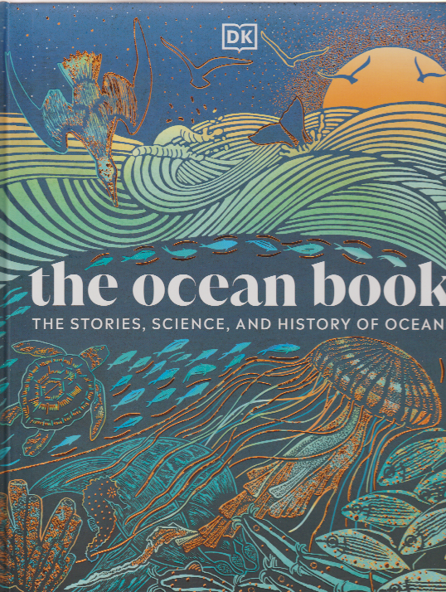
Dorling Kindersley, 2025. The Ocean Book: The Stories, Science and History of Oceans, Senior editor: H. Wilkinson. Dorrik Stow: Consultant and contributor

People have felt the call of the sea throughout history, yet the oceans remain the least explored part of our planet. Combining science with folklore, culture and history, The Ocean Book is an immersive guide to the marine world. Its vividly illustrated pages explore the sciences of oceanography and marine biology, with fascinating glimpses into associated mythology and cultures from around the world. Animal and plant species are explained with beautiful images, along with geographical and weather phenomena. For lovers of science and history alike, this is the ultimate companion to the sea.

