Heartbeat of the Earth:
Deep-Ocean Record of Tectonic Pulsing

If we could listen with a geological stethoscope to the Earth’s deep interior, I propose that we would detect a slow but strong heartbeat, of about one million year duration, with dramatic effect at the surface of the planet.

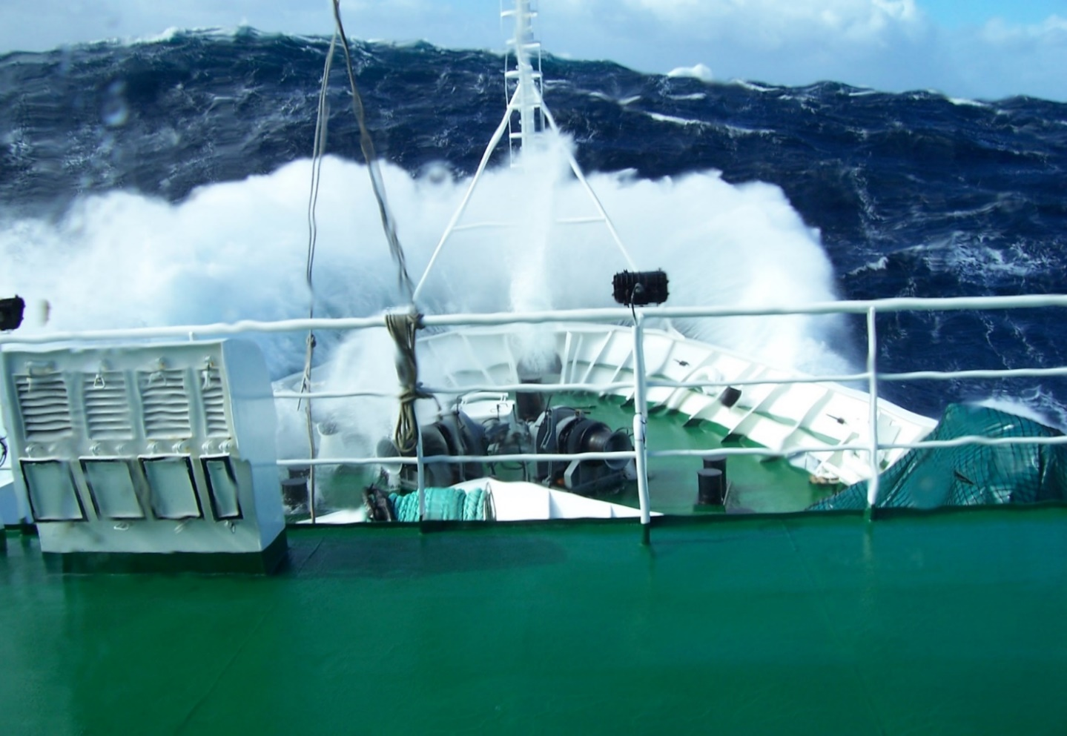
Storm at sea aboard the Sarmiento scientific vessel. Return across the Bay of Biscay from a marine
expedition in the Gulf of Cadiz, eastern North Atlantic Ocean

Cyclicity is a fundamental attribute of many Earth systems. It occurs at all scales, from the diurnal pulse of tides to global mass extinction events that appear to repeat every 50 million years or so. Some cycles are driven externally, such as the alternation of glacial-interglacial episodes over the past 2-3 million years. This climate cyclicity is well understood and linked to regular variation in Earth’s orbit, axial tilt and wobble that affect solar insolation with approximately 100, 40 and 20 ka periodicity. Other cycles are driven internally by the Earth’s own heat engine and plate tectonic movements. These lead to earthquakes, volcanoes and mountain building and, although we understand their cause, we don’t yet know how to measure their tectonic pulse.

I am a deep ocean geologist who has been studying some of the most remote and inaccessible parts of the planet – the deep seafloor and its sedimentary cover – for more than 40 years. I see that the normally quiet rain of fine particles and planktonic debris from the ocean surface to the seafloor is punctuated by catastrophic events – giant submarine slides, chaotic debris flows and powerful turbidity currents. During a recent scientific drilling expedition to the Gulf of Cadiz in the eastern North Atlantic, our results revealed just such catastrophic events at approximately 1 million year intervals. These did not correlate with climate or sealevel change, and we inferred tectonic pulsing as the cause, in part also controlling the closure and opening of the Straits of Gibraltar, and probably linked to deep-seated activity in the Earth’s mantle or core.

Some of my earlier research invoked a regular pulsing or piano-key tectonics as a control on sand/gravel distribution in Brae oilfield in the North Sea, and Himalayan uplift tectonics as a strong influence on turbidite sedimentation on the Bengal Fan, Indian Ocean. In both cases, these catastrophic events of sediment input appear to show a sub-regular periodicity of about 1 million years, exactly similar to the North Atlantic hot-spot pulsing proposed by others in order to explain episodic turbidite sand input into the North Sea between 50-60 million years ago. When I begin to look at other disparate events in Earth history – the flip-flop of magnetic polarity or the birth of new volcanoes in the Hawaiian islands – then I see a similar signal.

I believe there is something new and important to be unravelled from these varied observations, a novel process I call tectonic pulsing, which is the result of unknown deep-Earth processes – the very heartbeat of the Earth. My Leverhulme research seeks to elucidate the distribution, timing and cyclicity of such events, and to infer the cause. Validation of such a novel concept would herald a new paradigm in understanding the deep oceans, with wide-ranging implications for resource exploration, hazard mitigation and decoding the climate record.

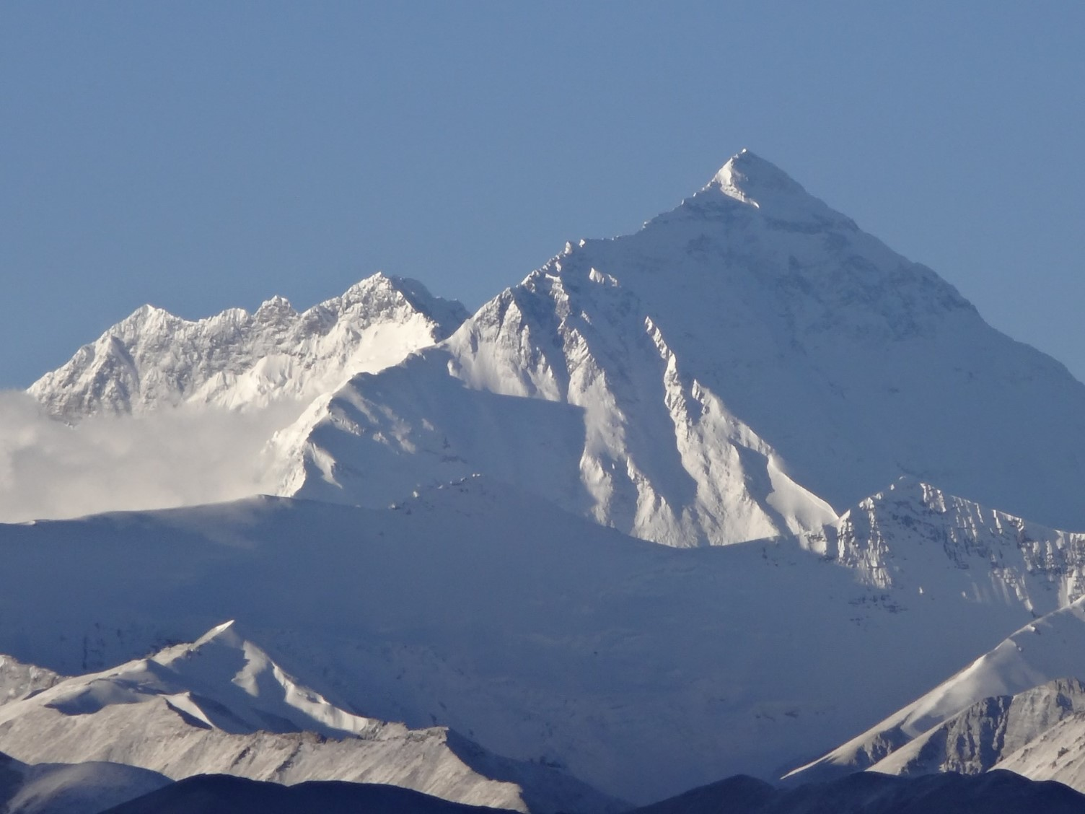
Mt Everest from Tibet (photo Dorrik Stow). The pulsed tectonic uplift of the Himalayan mountain range and Tibetan Plateau lead to major erosion events and sediment supply to the Bengal submarine fan in the deep Indian Ocean. Dorrik Stow proposes a one million year cyclicity based on the deep ocean record.

Professor Dorrik Stow FRSE, Heriot Watt University, Leverhulme Emeritus Fellow
: https://www.leverhulme.ac.uk/emeritus-fellowships/heartbeat-earth-deep-ocean-record-tectonic-pulsing

