Title
CARBONATE & CLASTIC SEDIMENTOLOGY & SEQUENCE STRATIGRAPHY: A FIELD COURSE, ALMERIA PROVINCE, SOUTHEAST SPAIN

Course lead
Professor Dorrik Stow Edinburgh, UK

Course summary
This is a field course on sedimentology and sequence stratigraphy, based in Almeria Province, southern Spain. It concerns the description and interpretation of sedimentary facies from different depositional environments, including deep marine, shallow marine and continental. It focuses on carbonate and clastic facies but also includes some evaporites and volcaniclastics. The field observations allow us to elucidate stratal stacking patterns and key bounding surfaces in order to erect a sequence stratigraphic framework. Traditionally, sedimentary successions are interpreted in terms of sea-level changes, using seismic sequence stratigraphic analysis in the first phases of exploration. Carbonate and clastic sequences respond very differently to sea-level, and both are strongly affected by tectonic activity, which may override sea-level effects in certain settings.

Topics covered
The course is designed primarily as a field course, but with part classroom/discussion content and part field delivery to directly examine examples of the course material in the field.

A. Field excursions. Itinerary selected from the following options:
- SORBAS village section: shallow marine sequence with at least two shallowing upward parasequences, transition from outer shelf to littoral environments, mixed carbonate-clastic
- SORBAS gorge section: littoral depositional environment, upward transition to continental succession, sequence stratigraphic boundaries, overview of transition to evaporite sedimentation
- POLOPOS section: deltaic succession (fan deltas), marine to terrestrial succession, sequence stratigraphic boundaries
- CARRIATIZ section: slope to reef succession, clear sequence stratigraphy linked to falling sea levels, carbonate succession
- AGUA AMARGA section: shallow marine carbonates, volcanic seamount and carbonate reef
- EL ARGAMASON section: thick vertical succession from outer shelf to littoral facies, clastic
- TABERNAS basin: deepwater succession with hemipelagites, turbidites and MTDs, overview of shallowing upward basin fill, carbonate-clastic

B. Classroom content
- Introduction, Stratigraphy, Sequence Stratigraphy
- Depositional Systems, Sedimentology
- Sequence Stratigraphy – Clastic Systems
- Sequence Stratigraphy – Carbonate Systems

Audience: geologists, geophysicists, petrophysicists

Course level: the course can be run at both foundation and skilled levels dependent on client requirements
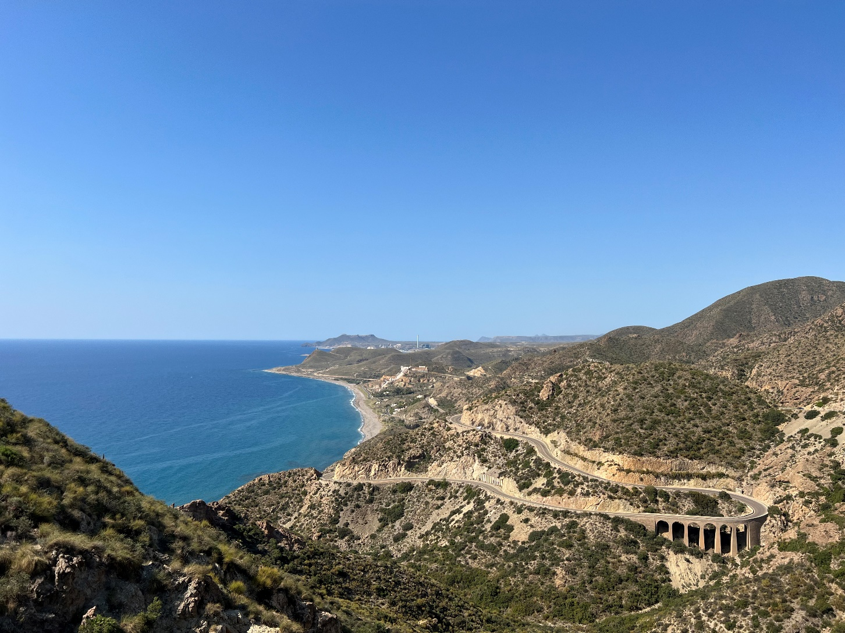

Cabo de Gata, Almeria Province, SE Spain. . Separated from the Neogene basins by an active strike-lip fault

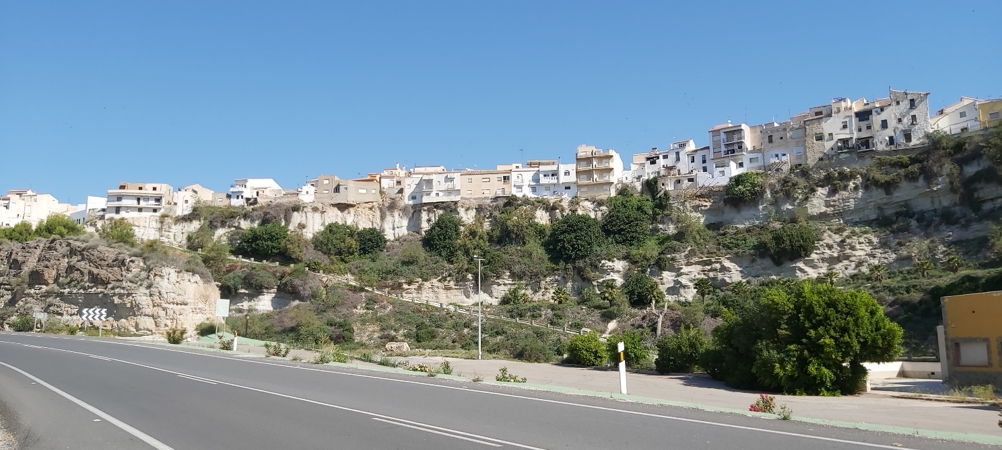

Sorbas village, Almeria, SE Spain sitting on top of shallowing-up coastal to littoral, mixed carbonate-clastic depositional parasequence

