CYPRUS FIELD VISIT: ophiolite, ocean crust and Tethys Ocean sediments – with archaeological remains, sunshine and wine
Field leader: Professor Dorrik Stow, Heriot Watt University, Edinburgh

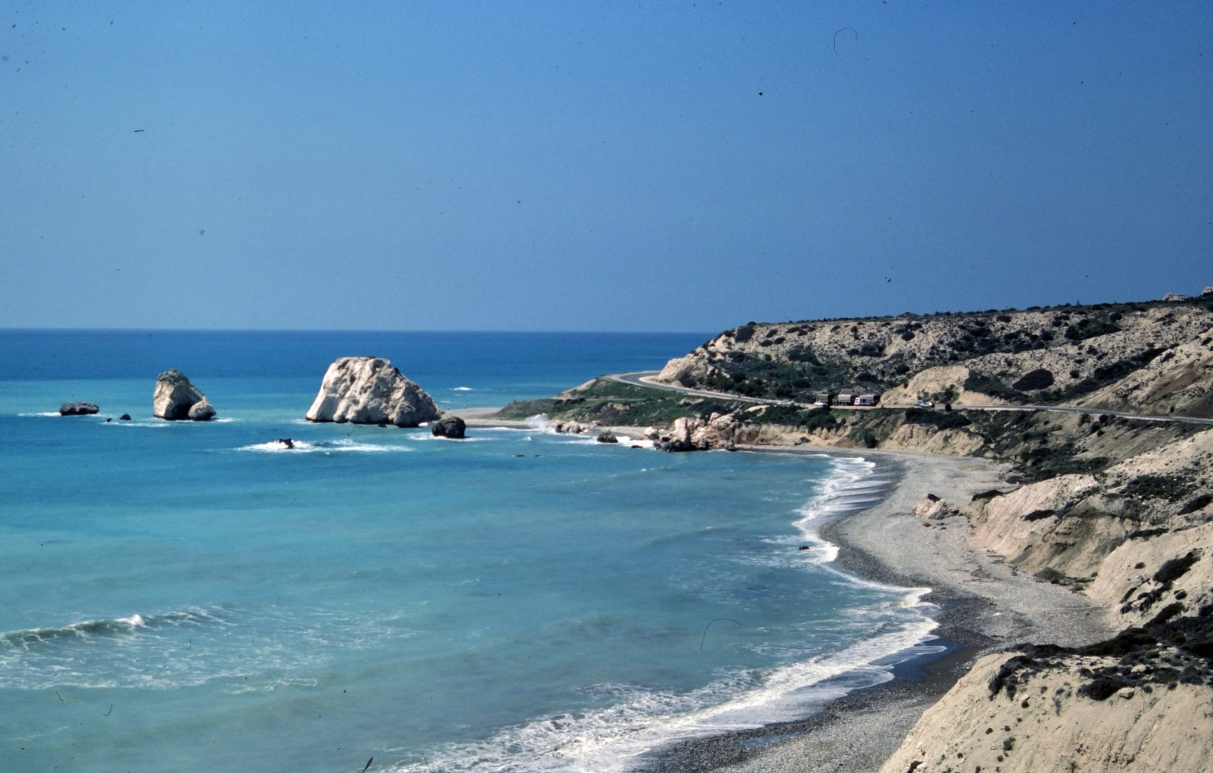

Accommodation: Pissouri Village/Pissouri Bay, SW Cyprus
Airports: nearest airport, Paphos; alternative airport Larnaca

Provisional itinerary – September 7-15th 2026:

CONTOURITES EXCURSIONS
7 APHRODITES BAY (pictured above): chaotic melange, Triassic reef talus, ocean-floor pillow lavas, deep-sea marls and clays. PISSOURI ROAD: type section for contourites.
CURIUM Roman Amphitheatre: remarkable remains in stunning coastal site. Trace fossils in limestone building blocks. Miocene reefs and reef talus. Visit to the nearby Roman Stadium.
8 KALAVASOS VILLAGE: contourite section, followed by exploration of the UNESCO world heritage site at KHIROKITIA, a 9000-year old Neolithic village community.
9 AGIOS GEORGIOS to AGIOS NIKOLAOS: contourite sections in Troodos foothills; return via PAKHNA with option to visit a local winery.

CYPRUS GEOLOGY - GENERAL
10 APHRODITES BAY(repeat of 7th for second group): chaotic melange associated with emplacement of the Troodos ophiolite. Triassic reef talus, ocean-floor pillow lavas, deep-sea marls and clays. PISSOURI ROAD: deepwater pelagic limestones, type section for contourites, passing upwards into shallow-marine facies. Basin-margin faulting.
11 TROODOS OPHIOLITE: classic section through an ophiolite, from mantle serpentinites, through gabbros, dyke swarms, and pillow-lava (ocean floor) basalts, to black smoker umbers. Touching the Moho discontinuity between crust and mantle.
12 PISSOURI village to beach: basin fill from Miocene evaporites though shallowing-upward succession to braid delta and paleosols (pictured below). Hyperpycnites, gypsum turbidites, calcarenite turbidites and debrites.
13 TOKHNI and KHIROKITIA: deep-sea submarine canyon fill, followed by exploration of the UNESCO world heritage site at Khirokitia, a Neolithic village community.
SALINITY CRISIS: thick gypsum deposits from the end-Miocene evaporation of the Tethys Seaway (ancestral Mediterranean), and tentative colonisation by microbial reef mounds.
14 YERMASOYIA DAM limestones and alluvial fan-delta.
AKROTIRI modern salt lake and flamingos
CURIUM Roman Amphitheatre: remarkable remains in stunning coastal site. Trace fossils in limestone building blocks. Miocene reefs and reef talus. Visit to the nearby Roman Stadium.
15 FREE DAY – further options available

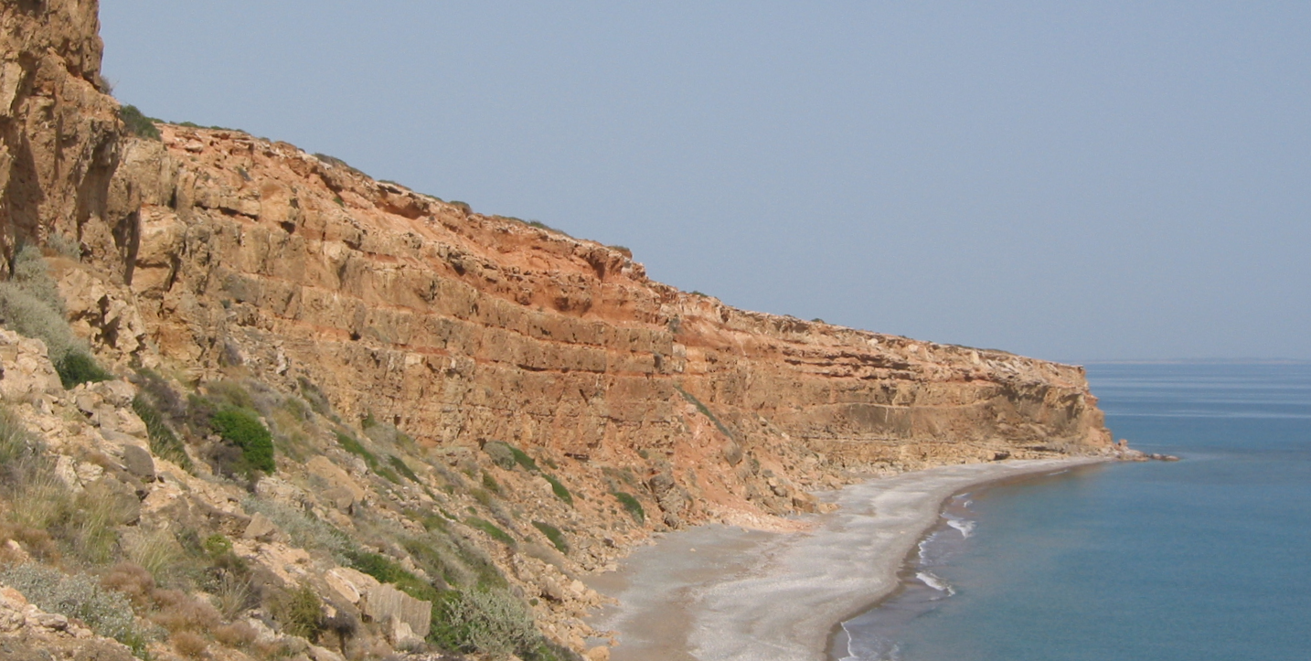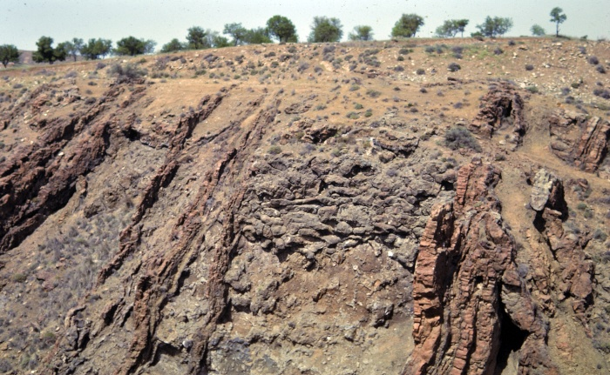
Pissouri coastal section – braid delta, paleosols Dyke swarm through pillow lavas

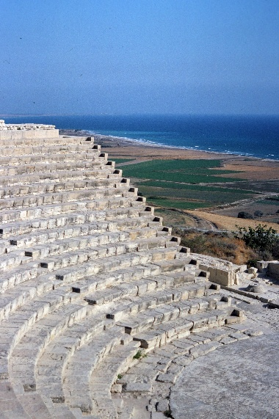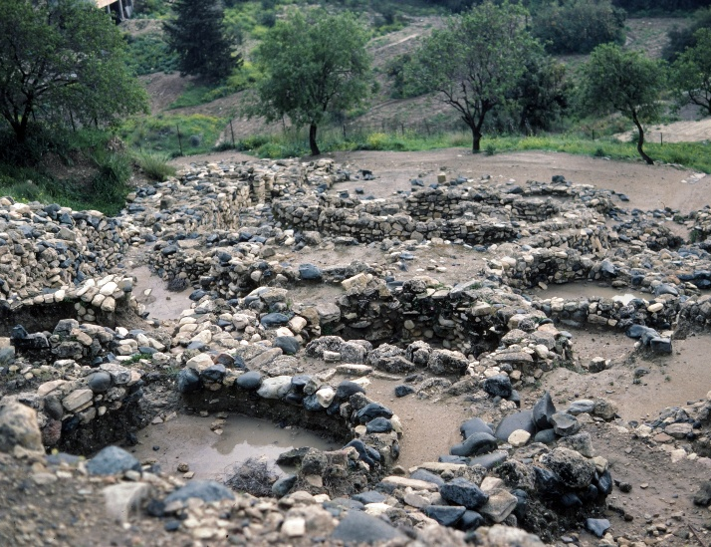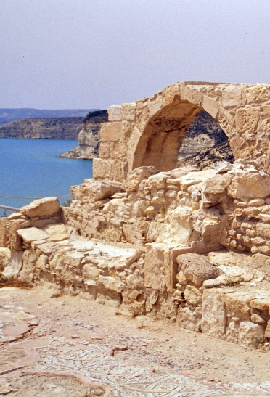
Archaeological sites: Curium and Khirokitia (Roman mosaics, amphitheatre, Neolithic village)

